Nama : Muhammad Gibaltar Putra Wibowo  
NIM : 2602145516

Website Inspiration

* <https://www.seirock-ya.asia/index.html>
* <https://www.ippudo.co.id/>

Ramen

* <https://pin.it/4tM4jk2>
* <https://pin.it/4lraszB>
* <https://www.seirock-ya.asia/assets/img/menu/1.jpg>
* <https://www.seirock-ya.asia/assets/img/menu/4.jpg>
* <https://www.seirock-ya.asia/assets/img/menu/2.jpg>
* <https://pin.it/3PKZ3tI>
* <https://id.pinterest.com/search/pins/?q=ramen%20from%20scratch&rs=typed>

tempura

* <https://pin.it/3sJmqL8>

Gyoza

* <https://pin.it/19t97Py>

karaage

* <https://pin.it/6gFxDCV>

ocha

* https://id.pinterest.com/search/pins/?q=japanese%20green%20tea&rs=typed

lemon tea

* <https://pin.it/74DVUqn>

soft drinks

* <https://pin.it/7HXYAUB>

Indonesia

* <https://w7.pngwing.com/pngs/224/282/png-transparent-red-and-white-map-illustration-flag-of-indonesia-map-national-flag-indonesia-map-flag-text-logo-thumbnail.png>

Japan

* <https://www.pngwing.com/en/free-png-nvmtc>

design desktop

Home

Menu

Promo

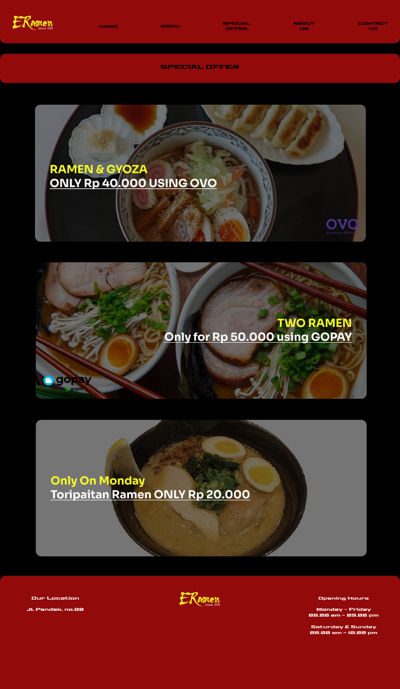

About Us

Contact Us

